Lab Report

Your Information
Your Name: Joshua Zimmerman-Gibson
Assignment Title: Navigating MongoDB with Restaurant Data

Screenshots
- List the names of all restaurants in the 'Manhattan' borough.
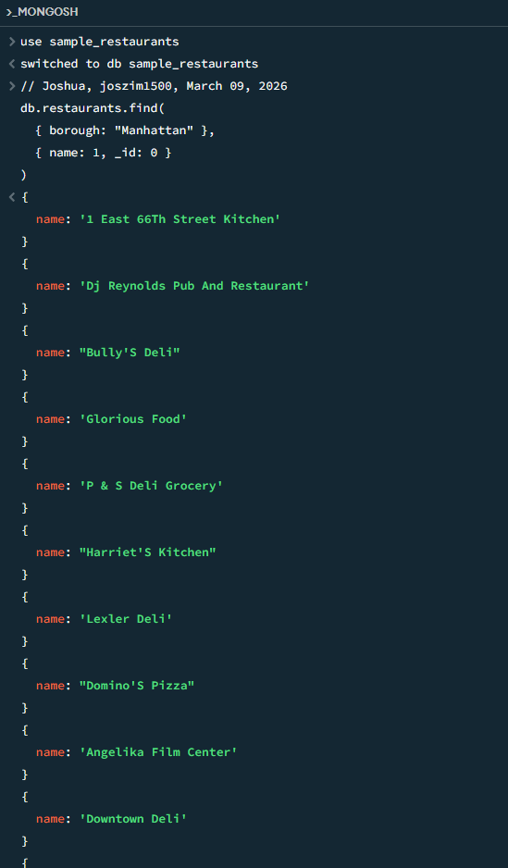
- Update the cuisine of 'Juni' restaurant to 'Modern European'.
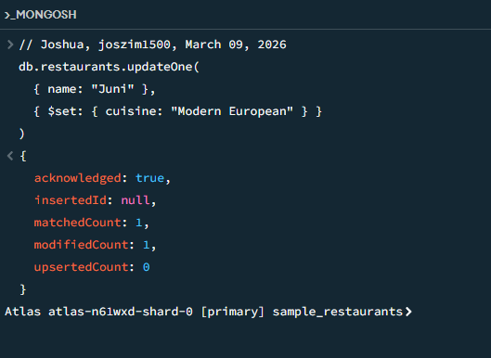
- Delete all restaurants that have been closed (where the 'restaurant_id' is null).
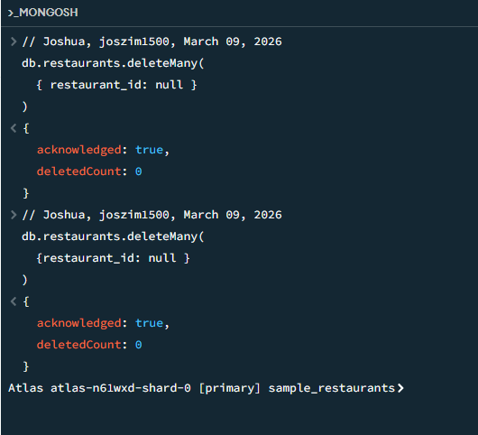
- Count how many restaurants serve 'Chinese' cuisine.
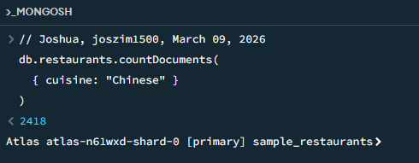
- Insert a new restaurant with details including name, borough, cuisine, and address.
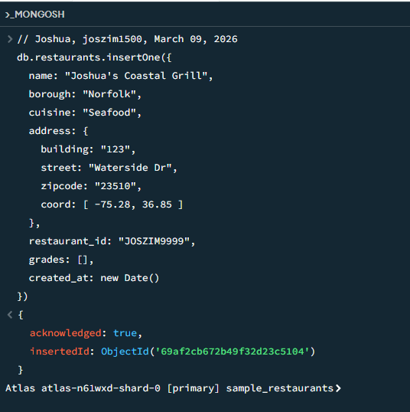
- Find restaurants within 500 meters of a specific longitude and latitude.
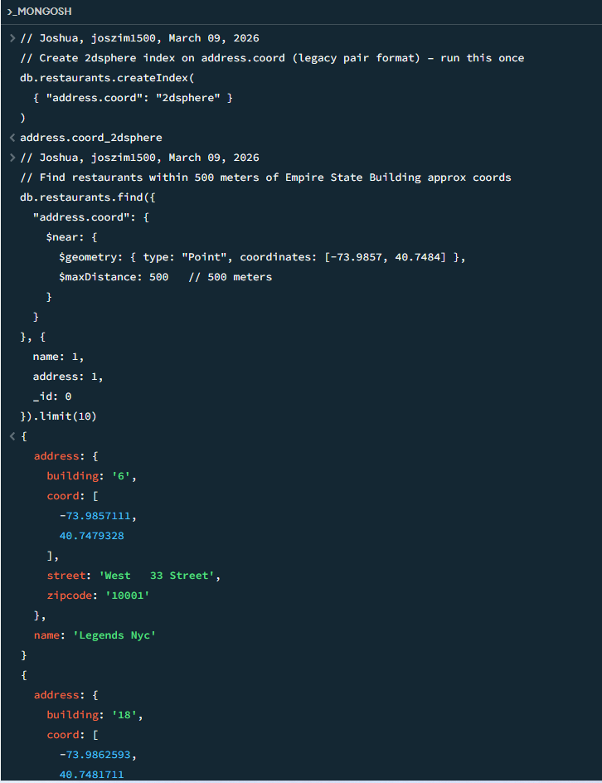
- Aggregate and count the number of restaurants for each 'cuisine' type.
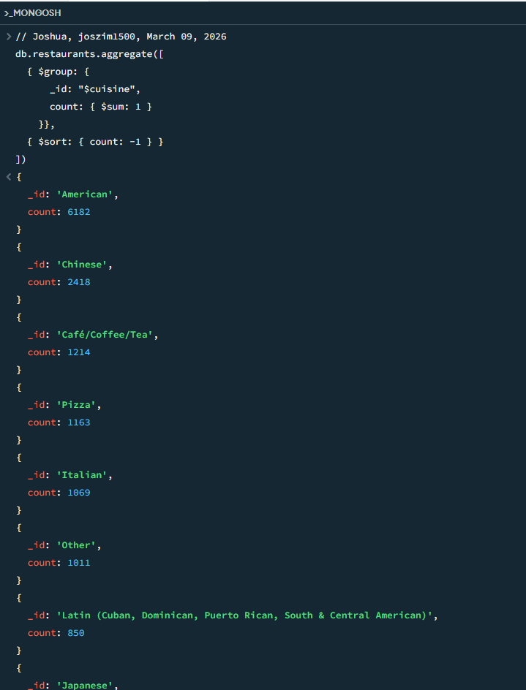
- Find the top 5 restaurants with the highest score in their latest grade.
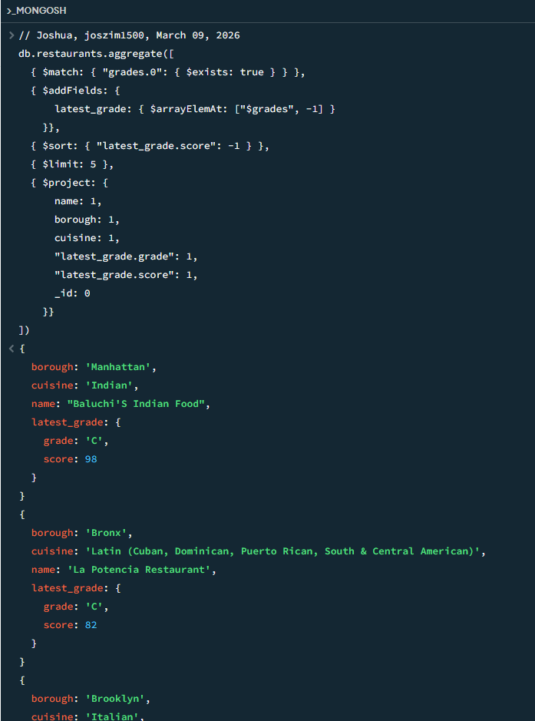
- Update all restaurants in the 'Queens' borough to add a 'parking' facility to their amenities.
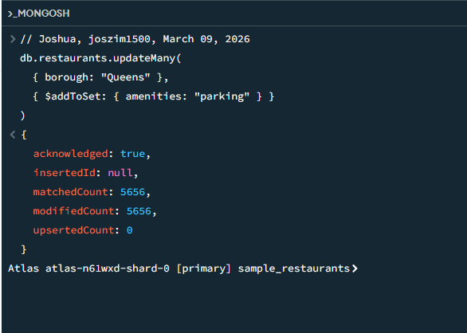
- Perform a text search for restaurants that include 'pizza' in their name.
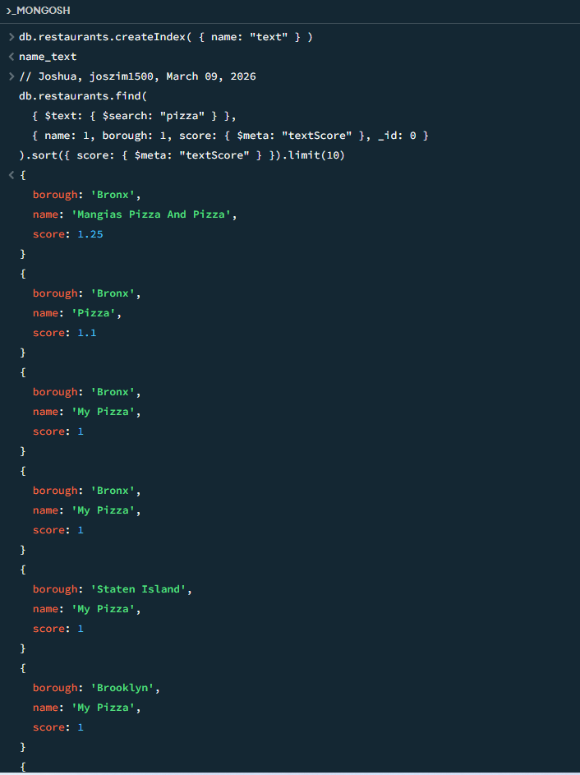

Questions
- Why is it important to create an index before performing a text search in MongoDB?
Without a text index, MongoDB has to look through every single document in the collection to find words, this is very slow (especially with thousands of restaurants). A text index is like making a "word list" (a phone book for words) so MongoDB can find matches super-fast.

- How does MongoDB handle geospatial data differently from traditional data, and what are the benefits of using MongoDB for geospatial queries?

Normal data = just numbers, text, dates. Geospatial data = locations on Earth (latitude + longitude).
MongoDB treats locations as special "points on a map" instead of just two numbers.
Main differences:
- You store coordinates as:
  - Old way: [longitude, latitude] array
  - Modern way: {type: "Point", coordinates: [longitude, latitude] } (GeoJSON format)
- You create a special index called 2dsphere (for Earth/spherical math) or 2d (flat map, less accurate).
- MongoDB knows how to calculate real distances on a round planet (not just straight-line math).
Big benefits of using MongoDB for location-based questions:
- Very fast "find things near me" queries (e.g., restaurants within 500 meters)
- Built-in operators like $near, $geoWithin, $nearSphere
- Handles curved Earth distances correctly (important for long distances)
- You can ask questions like:
  - "Show me all restaurants within 1 km"
  - "Find restaurants inside this polygon shape"
  - "Sort by closest first"

- What are some potential consequences of not specifying the correct field in an update operation, and how can you ensure updates are applied correctly?

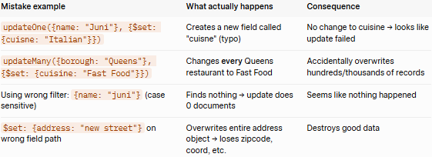
- Always double-check spelling — field names are case-sensitive (cuisine ≠ Cuisine).
- Test your filter first with .find()
- Use updateOne instead of updateMany when you only want to change one thing (safer).
- Add { upsert: false } and check the result.
- Use .preview() or run on a small test collection first if you're nervous.
- Make backups (or work on a copy of the database) before big updates.

